DATA STRUCTURES LAB

Pharmacy Management System



Jaypee Institute of Information and Technology, Noida

Submitted by:

Yash Agarwal 18103299

Jai Singh 18103069

Prasoon Mishra 18103077

INTRODUCTION

The project undertaken by our group is based on Pharmacy Management system. The main essence and motive of the project is to provide an easy and functional interface for both the buyer and seller of the medicine to easily meet their demands without any discrepency.

The interface developed allows multiple logins from both the seller and the customer side so as to provide an easy and effective work flow

DATA STRUCTURES INVOLVED:

The main kindler of the project are the data structures. There are various data structures used ranging from the simplest arrays to the complex tries.

The data structures implemented in our project are as follows:

* Arrays
* Strings
* Linked lists
* Multi linked lists
* Trie
* Structures
* Standard template library
  + Vectors
  + Lists

Other important concepts implemented in the project includes:

* Pointers
* File Handling

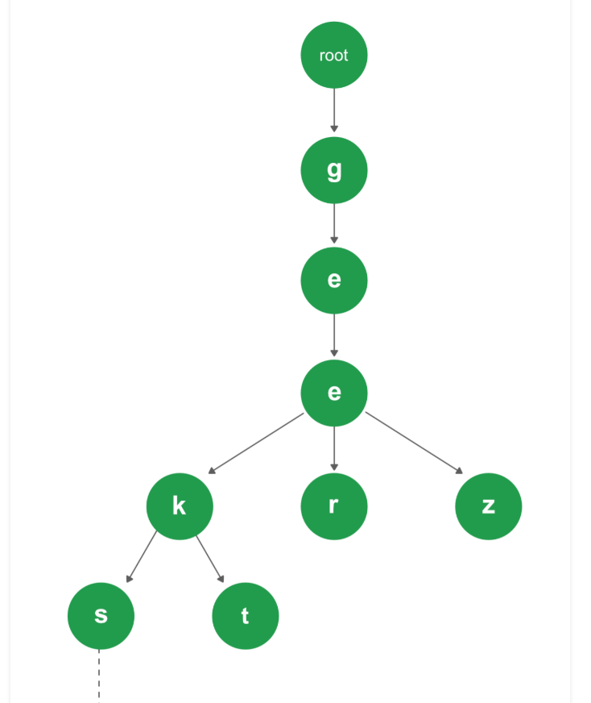

DATA STRUCTURES USAGE WORKFLOW:

There are various data structures implemented in our project and every one has their own separate use according to the need.

* The structures in our project have been defined multiple times to accomadate the entities like the seller or the buyer who have various characterstics which define them like their username or full name and password on login.

Also the storage of the medicine is done using links which keeps

Together the medicince which have similar disease remedial

Characterstics. The structure have also been used to store the

Medicine information like manufacturing date, name and expiry date.

* Trie is the form of tree data structure that provides O(N) time complexity for searching the word in comparison to the Nlog(N) for the binary search tree. This decrease in time complexity becomes extremely vital when considering the vast medical store line ups and companies who have thousands of rows of data. The trie is used to store the name of the medicine. Later this trie is used to provide efficient searching.
* The multi linked list is used in our project to store the names of medicine character by character and linking them together to form a complete body out of them
* Also various smaller data structures have been used like arrays , strings to store the integers and the name of the medicines, buyer , seller etc

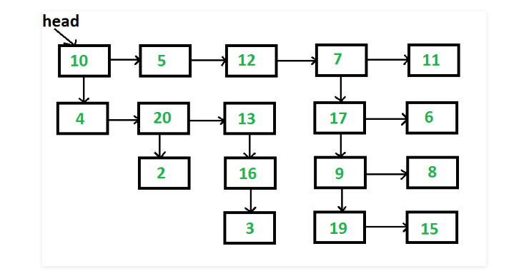

FILE HANDLING

Other important concepts used in our project includes file handling which is the key information provider for the projects.

There is a seperate file that has information about the medicine like their cost, stockpile count, manufacturing date, expiry date etc another file deals with the name of the medicine with the disease they are effective against.

There are files that contains the information about the login user and the seller.

Many of these files have to be provided with the write permission so as to append the data. For example we might need to add new users when they register at the interface and it becomes extremely important to provide the write permissions to such files otherwise the whole purpose of the project becomes questionable.

SOME IMPORTANT FUNCTIONS

* loadData(): the loadData function in the code loads data from the

Text files which have the information about the diseases and loads them into a multi linked lists. It does this for all the data in the file. It reads the data line by line, stores them in a vector.

* loginCustomer(): This function acts like an interface function. It asks for the credentials from the user and opens the login text file. Upon receiving the credentials the function validates it with the data present in the login file. If the credentials match with a particular the user is welcomed otherwise an error is thrown.

Similar functionality is applied to the loginSeller() function but this function is for the login functionality for the seller and it validates the data from a different file.

* registerCustomer(): This function is used to provide the functionality of registration for the user. It comes in handy when a new user tries to login and it’s information will be added in the login file in which the data of the login users has been added.

A similar functionality is provided for registerSeller() which registers a

New seller in the seller text files.

* Insert(): This function is used to create a node for trie which reduces the time complexity of the search from NlogN to logN. This difference does not plays a bigger role for smaller database but when the size of the database increases in the number of rows then this difference in time complexity comes into play a lot more.

Various functions like printalldata(), print_med_info(), print_info() are provided to provide a cleaner code as these act like template printing functions which print a predefined sets of values so that we dont have to “cout” multiple times as it makes the code look very unorganized.